Netflix Titles Report
- Project Objective
The objective of this project is to analyze Netflix's content catalog to identify trends in movies and TV shows, understand content distribution patterns, analyze country-wise production, and derive business insights using SQL.
Dataset
- Source: Netflix Titles Dataset
- Records: 8,800+ titles
Solving 15 business problems using the given datasets
1. Count the number of Movies vs TV Shows
SELECT
type,
COUNT(*) AS Total_number
FROM netflix
GROUP BY type
This query shows the count of the total number of Movies & TV shows. Using COUNT functions for Total number and GROUP BY type
--2. Find the most common rating for movies and TV shows
SELECT type, rating
FROM(
SELECT
type,
rating,
COUNT(*) AS Higher_number,
RANK() OVER(PARTITION BY type ORDER BY COUNT(*)DESC ) AS Rank_Number
FROM netflix
GROUP BY type, rating
) t WHERE Rank_Number = 1
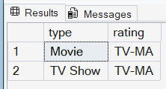
In this Question, I am solving for the most common rating for movies and TV Shows. I’ve implemented a window function in RANK to find the top numbers partition by type for both movies and TV shows, ordered by COUNT (*) and made a subquery to use the RANK function. Using the WHERE function, I can define the highest rating.
--3. List all movies released in a specific year (e.g., 2020)
SELECT
type,
title,
release_year FROM Netflix
WHERE type = 'Movie' AND release_year = 2020

Here we have to find the release year for 2020 listed with movies; it needs to just filter those using a WHERE clause to filter the type to Movie and the release year to 2020.
--4. Find the top 5 countries with the most content on Netflix
SELECT TOP 5
TRIM(value) AS country,
COUNT(*) AS Most_content
FROM netflix
CROSS APPLY STRING_SPLIT(country, ',')
GROUP BY TRIM(value)
ORDER by COUNT(*) DESC
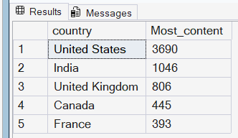
According to the query, there has to be a change in String_Split; the country columns contain multiple countries in one cell, so it needs to be separated to get the accurate values. Total count of content and trimming the value of the country columns. Using GROUP BY and ORDER BY clause to get the highest number. Finally, to get the top 5 values, used TOP 5.
--5. Identify the longest movie
SELECT
title,
duration,
type
FROM dbo.netflix
WHERE
type = 'Movie' AND
duration = (SELECT MAX(duration) FROM netflix)
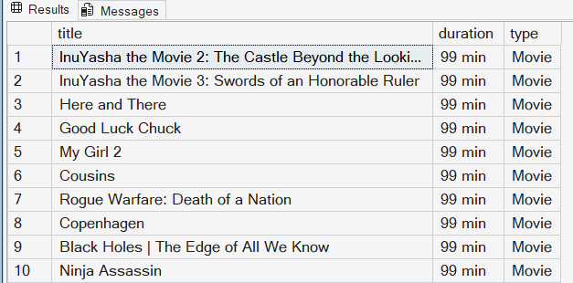
This query finds the longest movie by filtering for the Movie type and Duration, and sorting by Duration; the highest Duration movies are at the top of the list.
--6. Find content added in the last 5 years
SELECT *,DATEPART(YEAR, date_added) AS Year_
FROM netflix
WHERE YEAR(date_added) >= YEAR(GETDATE()) - 5
ORDER BY Year_
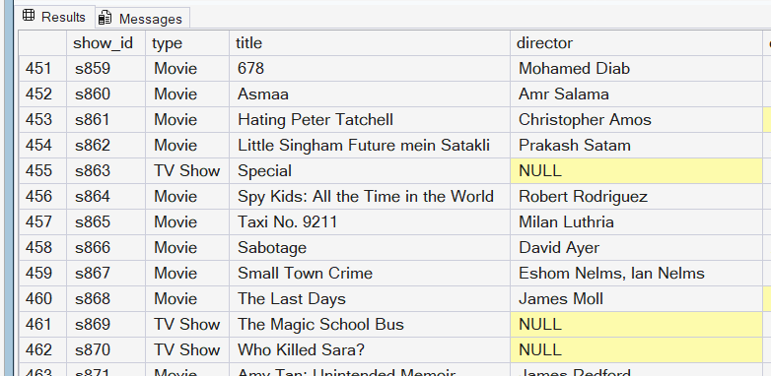
Here in this query, I have made sure to get the content from the last 5 years. I have already mentioned 2021 because I have mentioned getting from the present date, which is 2026 right now, so it has only captured 2021 data. I have used the DATEPART function to consider the year from the date. WHERE clause about the year greater than the present date.
--7. Find all the movies/TV shows by director 'Rajiv Chilaka'!
SELECT title,director
FROM Netflix WHERE director LIKE '%Rajiv Chilaka%' AND type = 'movie'
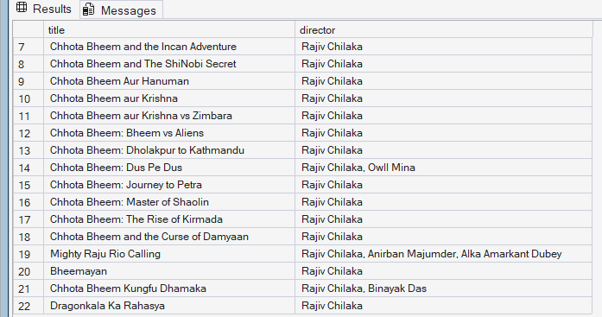
In this query, I have to find movie which are directed by Rajiv Chilaka. So, using the WHERE clause, I have filtered the columns and found the movies only directed by Rajiv Chilaka. There are some issues we need to fix in the director column for some movies; there are multiple directors. So, I use LIKE and added ‘%’ at the start and end of the name, so if there are any more records, I still need the table
--8. List all TV shows with more than 5 seasons
SELECT * FROM netflix
WHERE type = 'TV Show'
AND TRY_CAST(LEFT(duration, CHARINDEX(' ', duration) - 1) AS INT) > 5; ---
--- TRY_CAST= Converts the numeric string to compare with integer
--- CHARINDEX = Find the exact position of the space character
-- LEFT () =Grabs the character before the space if -1 consider the backwards number or 1 consider the forward number -- LEFT -3-2,-1,VALUE ,1,2,3 RIGHT
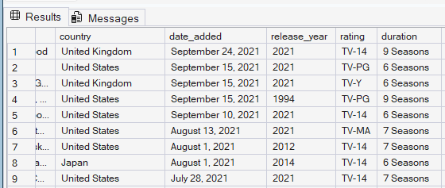
This Query to find the duration of tv show that are more than 5 seasons. I have used TRY_CAST to convert the data type to string to numeric to identify the greater-than value. LEFT function is used to show the position of the aggregated value; CHARINDEX is used to spot and ensure the exact position of the space, and then, as we need greater than 5 at the end.
--9. Count the number of content items in each genre
SELECT count(*) AS Number_content,
TRIM(value) AS Genre
FROM netflix
CROSS APPLY STRING_SPLIT (listed_in, ',')
GROUP BY TRIM(value)
ORDER BY count(*) DESC
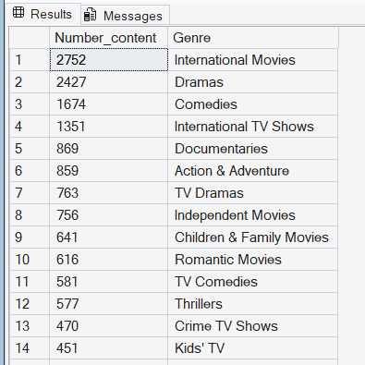
According to this query, I was able to find the number of genres for each. I have used the COUNT () function to get the total of the number content, Secondly Trim the values of genre to remove the extra unwanted spaces, and later applied STRING_SPLIT, as the column has a lot of values in one cell, so I need to split it. Now I have found the total number of contents with these formulas
--10.Find each year and the average numbers of content release in India on Netflix. return top 5 year with highest avg content release!
SELECT Year_, Total_Count,
-- Calculate percentage contribution: (Yearly Count / Grand Total) * 100
ROUND( CAST(Total_Count AS FLOAT) / (SELECT COUNT(*) FROM netflix WHERE country = 'India') * 100, 2 ) AS avg_content_per_year
FROM ( SELECT
DATEPART(YEAR, date_added) AS Year_,
COUNT(*) AS Total_Count
FROM netflix
WHERE country = 'India' AND date_added IS NOT NULL
GROUP BY DATEPART(YEAR, date_added)
) t ORDER BY Year_; -- Calculating average percentage for each year for India country
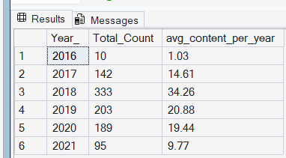
Calculating the average per year for India country; I need to do a subquery for the COUNT (*) , DATEPART for year, and filter country India. This is an inner query and Outer query. I have calculated the average here is formula -- Calculate percentage contribution: (Yearly Count / Grand Total) * 100. So, the results come at the end of each year average
--11. List all movies that are documentaries
SELECT * FROM netflix
CROSS APPLY string_split(listed_in,',')
WHERE listed_in LIKE '%documentaries%'
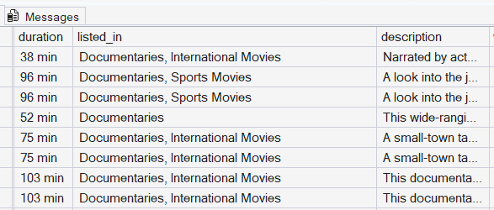
This query shows all movies that are documentaries. I’ve included string_split to add the separation and count the value in the field. WHERE is filtering the listed_in column only to return the value named documentaries with % at the start and end if there in different pattern.
--12. Find all content without a director
SELECT * FROM Netflix WHERE director IS NULL
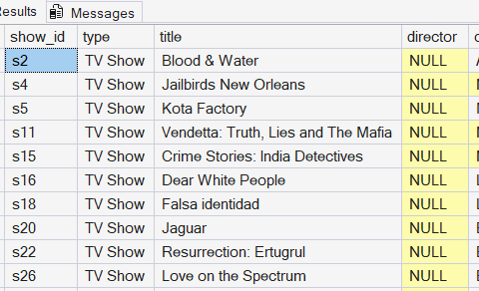
This query finds NULL; need to pull the data with NULL in the director field.
--13. Find how many movies actor 'Salman Khan' appeared in last 10 years!
SELECT * FROM netflix
WHERE cast LIKE '%Salman Khan%'
AND release_year > YEAR(GETDATE()) -10
--There is release_year INT and (getdate) DATETIME So We only need year to get to calculate
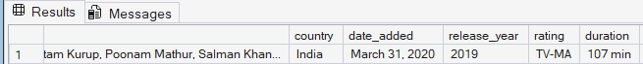
In this query, we found that one row in the table while filtering GETDATE in the last 10 years
Simply populate the WHERE clause to find the name in the field and sort it by the current year 10 years back
--14. Find the top 10 actors who have appeared in the highest number of movies produced in India.
SELECT TOP 10
TRIM(value) AS Actor_name,
COUNT(*) AS Total_content
FROM Netflix
CROSS APPLY String_split(cast, ',')
WHERE country LIKE '%India'
GROUP BY TRIM(value)
ORDER BY Total_content DESC
-- STRING_SPLIT to split all the record in the field in arrange them in each row in one single columns
-- And aggregate with count of total content and filter it with India and order
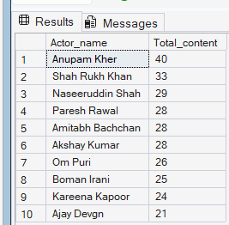
In this query, I have executed the total number of actors who have a highest number of contents in the table, specifically for the country India. There are many values in a field that contain many values populated in string split and separated into many rows, with values in a single column. It can filter for the India country and calculate the count accurately.
--15. Categorize the content based on the presence of the keywords 'kill' and 'violence' inthe description field. Label content containing these keywords as 'Bad' and all other content as 'Good'. Count how many items fall into each category.

SELECT COUNT(*) AS Total_content, Review
FROM(
SELECT *,
CASE WHEN description LIKE '%kill%' THEN 'Bad'
WHEN description LIKE '%violence%' THEN 'Bad'
ELSE 'Good'
END AS Review
FROM netflix
)t GROUP BY Review
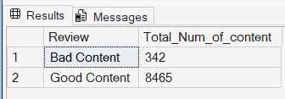
In this Query, I’ve leveraged the total count of the content that falls in their category. I’ve populated the CASE WHEN to write a statement whether kills and violence are found in the columns, then throw Bad content or else Good Content storing at a inner query and an outer query for the count of the content, which contains an integer, and GROUP BY Review, which was assigned an alias to the CASE statement.
- Technical Implementation
SQL Concepts Used
This project demonstrates:
Aggregations
Used:
COUNT ()
GROUP BY
ORDER BY
For:
- Content counts
- Genre analysis
- Country analysis

Window Functions
Used:
RANK ()
OVER(PARTITION BY)
Purpose:
Identify highest-ranking categories.

String Manipulation
Used:
STRING_SPLIT()
TRIM()
LIKE
Purpose:
Clean and analyze multi-value fields.

Conditional Logic
Used:
CASE WHEN
Purpose:
Classify content based on keywords.
- Business Recommendations
Based on analysis:
- Recommendation 1
Netflix can increase investment in international content, especially from high-performing markets such as India.
- Recommendation 2
Since mature-rated content dominates the platform, Netflix could evaluate opportunities for more family-oriented content.
- Recommendation 3
Genre analysis can help identify underserved categories with growth opportunities.
- Conclusion
This project demonstrates the ability to clean, transform, and analyze real-world datasets using SQL. The analysis provides insights into Netflix's content strategy, audience targeting, and global distribution patterns.

